INFORMATION AND REGULATIONS Tournament Committee
Chairman: Joe Law
Referee: Gary Lai
Control Desk: Sue Li
Equipment
Table & Net – Butterfly and JOOLA
Balls – 40+ mm Butterfly or other ITTF approved 3 star ball
Eligibility
− Eligibility for all ratings limited events (e.g. U-4000, i.e. less than 4000 rating points) and seeding in the draws are based on the current VTTC Ratings or current Table Tennis Canada ratings. In teams, the ratings refer to the combined ratings of the pair. The decision of the League Committee is final
-- If the event started at the same time, you are only allowed to join 1 event.
− The Tournament Committee may estimate the rating of any unrated player or non-Canada rating at any time during the tournament and remove that player from any event for which such a rating would make the player ineligible.

Formats
− All team events will play round robin with top 2 teams advanced to knockout stage.
− All events will be best 2 of 3 games to 11 points for group stage, and best 3 of 5 games to 11 points for knockout stage.
− Team Events: Two players, playing 4 singles and 1 doubles. The order of play: A v X, B v Y, doubles, A v Y, B v X. The team winning the first 3 matches wins the team match.
− Each group has 3 or 4 teams, top 2 teams advance
− Maximum entries for each event is 16 teams for U-4000, and 20 teams for all other events.
− First come first served.

Rules
− Latest ITTF rules will be in effect.
− All rackets must be one side black and one side red with ITTF approved coverings.
− Tie-breaks in round-robins will be decided successively by score of matches points, games, points, as far as is necessary to resolve the order only of those players involved in the tie.
− Tracksuit or any part thereof may not be worn during play except by special permission of the Referee. Athletic shorts and short sleeved or sleeveless shirt must be worn during match. Color of playing shirt must not be Orange or Yellow
− Events with less than 4 entries may be cancelled or combined with another event at the discretion of the Tournament Committee.
− Unpaid entries at the time of the Draw will NOT be included in the tournament.
− The Tournament Committee reserves the right to cancel any event due to insufficient entries, and the right to adjust any event time slot due to space available.
− The Tournament Committee will not be held liable for any unclaimed prizes and award
− Due to time restriction, Committee may change the rules and formats accordingly.
-- All decisions of the League Committee are final.

UMPIRING
− In general, players will be required to umpire their own matches. Umpires will be provided for finals.
因應贊助商所提供的獎品, VTTC 有權對賽項的獎品作出更改。VTTC 將會送出所有贊助商所提供的獎品, 每位參賽者將有機會獲得獎品。所有頒發獎品不可轉換。

Presented by
Vancouver Table Tennis Club


February 15, 16, and 17
(Saturday, Sunday & Monday)

VENUE: 3925 Fraser Street, Vancouver, BC, V5V 4E5

ENTRY

− Entry forms will NOT be accepted and processed unless accompanied by exact fees.
− Entry deadline: 7:00 pm, Wednesday, February 12
− Make cheque payable to Vancouver Table Tennis Company Ltd.
− DO NOT send cash by Mail.
− Draw: 8:00 pm, Thursday February 13
− No changes or refund offered after the draw

Send entry by mail to: V.T.T.C.
3925 Fraser Street, Vancouver, BC, V5V 4E5

For further information, please call: Joe Law (604) 215-0288
Sue Li (604) 771-9188

Or the website: http://vttc.ca/

Thank you for the following sponsors (特別 鳴謝贊助全場獎金和獎品):

FORTUNE WELL

LEVELUK JRII
Vancouver Table Tennis Club
2020 VTTC AKBAR Open and FW Team Challenge
February 15, 16 and 17 Entry Form (VTTC-Sanctioned) Please print:
Last Name:___________________ ____ First Name:______________________
Email:_______________________________ OR Address:_________________
City:_________ _Postal Code:______ Phone no:_____________________
Birth Date:(yyyy-mm-dd): _______________ Gender (M/F):________________
Rating:_________

Events | Fees | Partner
U-4000 Teams (max 16 teams) | □ $60 (per team) | Name: ____________________  Rating: ___________________
U-3000 Teams (max 20 teams) | □ $50 (per team) | Name: ____________________  Rating: ___________________
U-2000 Teams (max 20 teams) | □ $40 (per team) | Name: ____________________  Rating: ___________________
U-1000 Teams (max 20 teams) | □ $35 (per team) | Name: ____________________  Rating: ___________________
Open Singles | □ $30
U-2100 | □ $25
U-1800 | □ $25
U-1500 | □ $20
U-1000 | □ $20
U-500 | □ $18
U-200 | □ $18
U-12-Boy | □ $15
VTTC Rating Fee ($ 5.00 per person):$_______________
Total Amount Due: $_______________

I hereby agree to abide by all tournament rules and all decisions
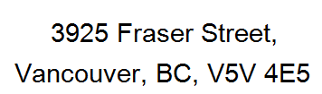
of the tournament committee and to release VTTC.,
the Tournament Committee from responsibility for any loss,
damages or injuries, occurring in the tournament.
____________________________ ____________

Signature (Parent's or guardian's signature if junior) Date

Saturday, February 15 | 9:00 am | U-3000 Teams / U-1000 Teams
Sunday, February 16 | 9:00 am | U-4000 Teams / U-2000 Teams
Monday, February 17 | 9:00 am | U-1800 / U-500
Monday, February 17 | 10:30 am | U-2100 / U-200
Monday, February 17 | 12:00 pm | U-1500
Monday, February 17 | 2:30 pm | Open Singles
Monday, February 17 | 4:15 pm | U-12-Boy
Monday, February 17 | 5:30 pm | U-1000
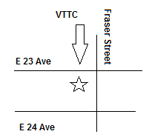

Events | 1st | 2nd | 3rd / 4th
U-4000 Teams | $500 + 2 Certificates  + LeveLuk Jr II | $300 + 2 Certificates | $150 + 2 Certificates
U-3000 Teams | $300 + 2 Certificates | $200 + 2 Certificates | $100 + 2 Certificates
U-2000 Teams | $200 + 2 Trophies | $100 + 2 Trophies | $50 + 2 Trophies
U-1000 Teams | $150 + 2 Trophies | $100 + 2 Trophies | $50 + 2 Trophies
Open Singles | $400 + Certificate | $200 + Certificate | $100 + Certificate
Open Singles | * $80 + Certificate | * $40 + Certificate | * $20 + Certificate
U-2100 | $150 + Certificate | $75 + Certificate
U-1800 | $100 + Certificate | $50 + Certificate
U-1500 | $80 + Certificate | $40 + Certificate
U-1000 | $50 + Certificate | $25 + Certificate
U-500 | Trophy | Trophy
U-200 | Trophy | Trophy
U-12-Boy | Trophy | Trophy
* For women players in the open singles event
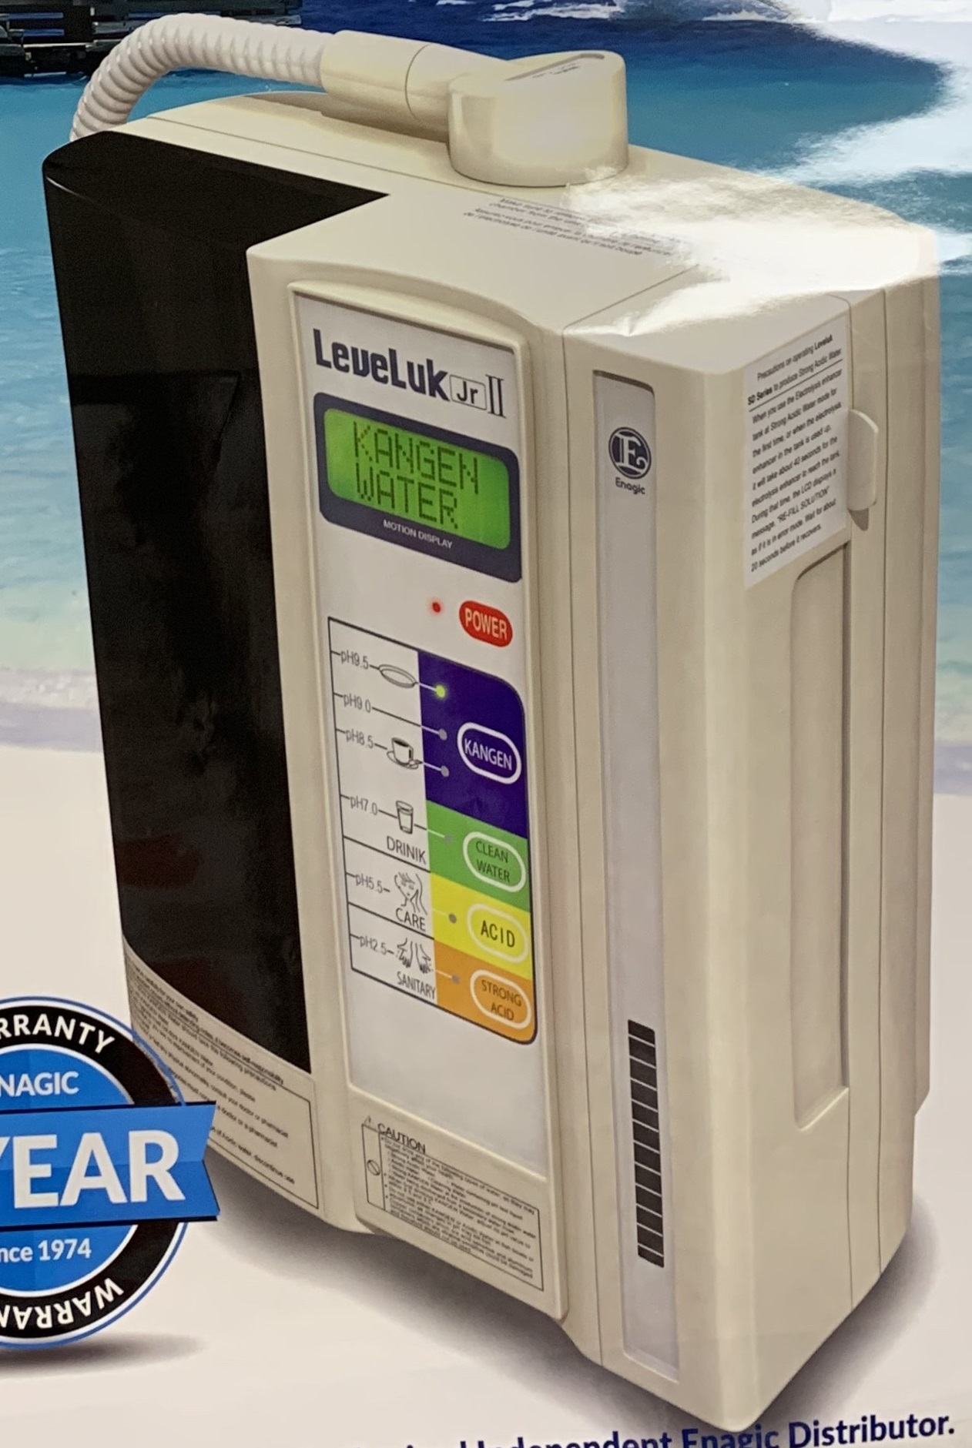
LeveLuk Jr II
Enagic Kangen Water Ionizer

